# 1.INTRODUCTION

Facial expression is one of the most remarkable, normal and widespread signs for people to pass on their passionate states and expectations. Various examinations have been directed on programmed outward appearance investigation in view of its down to earth significance in agreeable mechanical technology, clinical treatment, driver weakness reconnaissance, and numerous other human-PC association frameworks. In the field of PC vision and AI, different outward appearance acknowledgment (FER) frameworks have been investigated to encode demeanor data from facial portrayals. As right on time as the twentieth century, Ekman and Friesen characterized six essential feelings dependent on cross-culture study, which demonstrated that people see certain fundamental feelings similarly paying little mind to culture. These prototypical outward appearances are outrage, appall, dread, satisfaction, pity, and shock. Scorn was hence included as one of the essential feelings.

In spite of the fact that the influence model dependent on fundamental feelings is restricted in the capacity to speak to the intricacy and nuance of our day by day full of feeling shows, other feeling portrayal models, for example, the Facial Action Coding System (FACS) and the ceaseless model utilizing influence measurements are considered to speak to a more extensive scope of feelings, the clear cut model that depicts feelings as far as discrete essential feelings is as yet the most mainstream viewpoint for FER, because of its spearheading examinations alongside the immediate and instinctive meaning of outward appearances. Furthermore, in this overview, we will restrain our conversation on FER dependent on the all out model. FER frameworks can be partitioned into two primary classifications as indicated by the element portrayals: static picture FER and dynamic succession FER. Such as invented manual codes for spoken languages, home sign, "baby sign", and signs learned by non-human primates.

1. **SYSTEM ANALYSIS**

System Analysis is the important phase in the system development process. The System is studied to the minute details and analyzed. The system analyst plays an important role of an interrogator and dwells deep into the working of the present system. In analysis, a detailed study of these operations performed by the system and their relationships within and outside the system is done. A key question considered here is, “what must be done to solve the problem?” The system is viewed as a whole and the inputs to the system are identified. Once analysis is completed the analyst has a firm understanding of what is to be done.

## PROBLEM DEFINITION

A general statement of face recognition problem can be formulated as the given still or video images of a scene, identify or verify one or more persons in the scene or in any live capturing devices using a stored database of those authorised faces.

## EXISTING SYSTEM

As there is no staff available in unmanned restaurants, it is difficult for the restaurant management to estimate how the concept and the food is experienced by the customers. Existing rating systems. Such as Google and Trip Advisor, only partially solve this problem, as they only cover a part of the customer’s opinions. These rating systems are only used by a subset of the customers who rate the restaurant on independent rating platforms on their own initiative. This applies mainly to customers who experience their visit as very positive or negative.

## DISADVANTAGES OF EXISTING SYSTEM

* + - * Very high computation.
      * Less efficiency
      * Less accurate

## PROPOSED SYSTEM

In order to solve the above problem, all customers must be motivated to give a rating. This project introduces an approach for a restaurant rating system that asks every customer for a rating after their visit to increase the number of ratings as much as possible. This system can be used unmanned restaurants; the scoring system is based on facial expression detection using deep learning algorithms. It allows the customer to rate the food by taking or capturing a picture of his face that reflects the corresponding feelings. Compared to text-based rating system, there is much less information and no individual experience reports collected.

## ADVANTAGES OF THE PROPOSED SYSTEM

* + - * Faster
      * Easier to Use

## FEASIBILITY STUDY

The feasibility of the project is analysed in this phase and business proposal is put forth with a very general plan for the project and some cost estimates. During system analysis the feasibility study of the proposed system is to be carried out. This is to ensure that the proposed system is not a burden to the company. For feasibility analysis, some understanding of the major requirements for the system is essential.

Three key considerations involved in the feasibility analysis are

* Economical Feasibility
* Technical Feasibility
* Social Feasibility

## ECONOMIC FEASIBILITY

This study is carried out to check the economic impact that the system will have on the organization. The amount of fund that the company can pour into the research and development of the system is limited. The expenditures must be justified. Thus the developed system as well within the budget and this was achieved because most of the technologies used are freely available. Only the customized products had to be purchased.

## TECHNICAL FEASIBILITY

This study is carried out to check the technical feasibility, that is, the technical requirements of the system. Any system developed must not have a high demand on the available technical resources. This will lead to high demands on the available technical resources. This will lead to high demands being placed on the client. The developed system must have a modest requirement, as only minimal or null changes are required for implementing this system.

## SOCIAL FEASIBILITY

The aspect of study is to check the level of acceptance of the system by the user. This includes the process of training the user to use the system efficiently. The user must not feel threatened by the system, instead must accept it as a necessity. The level of acceptance by the users solely depends on the methods that are employed to educate the user about the system and to make him familiar with it. His level of confidence must be raised so that he is also able to make some constructive criticism, which is welcomed, as he is the final user of the system.

# HARDWARE & SOFTWARE REQUIREMENTS

## HARDWARE REQUIREMENTS:

Hardware interfaces specify the logical characteristics of each interface between the software product and the hardware components of the system. The following are some hardware requirements.

* Processor : I3/Intel Processor
* Hard Disk : 160GB
* RAM : 8Gb

## SOFTWARE REQUIREMENTS:

Software Requirements specifies the logical characteristics of each interface and software components of the system. The following are some software requirements.

* Operating System : Windows 7/8/10 .
* IDE : Pycharm.
* Libraries Used : Numpy, IO, OS, OpenCV.
* Technology : Python 3.6+.

# 3.ARCHITECTURE

This project is totally based upon identifying the recognised authorized faces. The model is built with libraries like face recognition, pyttsx, os, opencv, pandas, numpy etc. Each library is used for a specific purpose for example face recognition is used for face detection and manipulation of images. This project architecture shows the procedure followed for classification, starting from input to final prediction.This project architecture shows the procedure followed for classification, starting from input to final prediction.

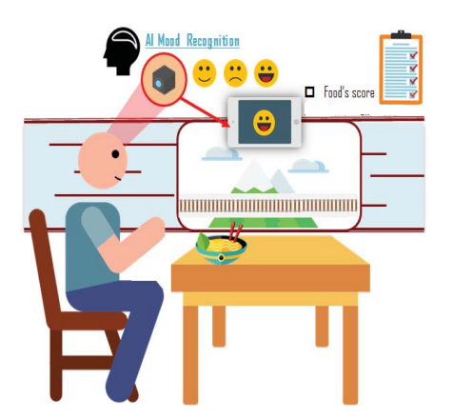

Figure 3.1: Project Architecture for Facial Expression Recogination In Restaurants Based On Scoring.

## USE CASE DIAGRAM

A use case diagram in the Unified Modeling Language (UML) is a type of behavioral diagram defined by and created from a Use-case analysis. Its purpose is to present a graphical overview of the functionality provided by a system in terms of actors, their goals (represented as use cases), and any dependencies between those use cases. The main purpose of a use case diagram is to show what system functions are performed for which actor. Roles of the actors in the system can be depicted.

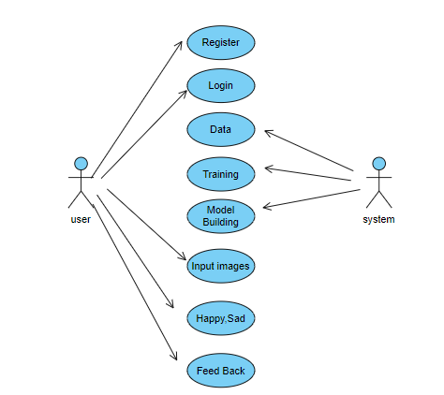

Figure 3.2: Use Case Diagram For Facial Expression Recogination For Restaurants Based On Scoring.

## CLASS DIAGRAM

In software engineering, a class diagram in the Unified Modeling Language (UML) is a type of static structure diagram that describes the structure of a system by showing the system's classes, their attributes, operations (or methods), and the relationships among the classes. It explains which class contains information.



Figure 3.3: Class Diagram For Facial Expression Recogination For Restaurants Based On Scoring.

## SEQUENCE DIAGRAM

A sequence diagram shows object interactions arranged in time sequence. It depicts the objects involved in the scenario and the sequence of messages exchanged between the objects needed to carry out the functionality of the scenario. Sequence diagrams are typically associated with use case realizations in the logical view of the system under development.

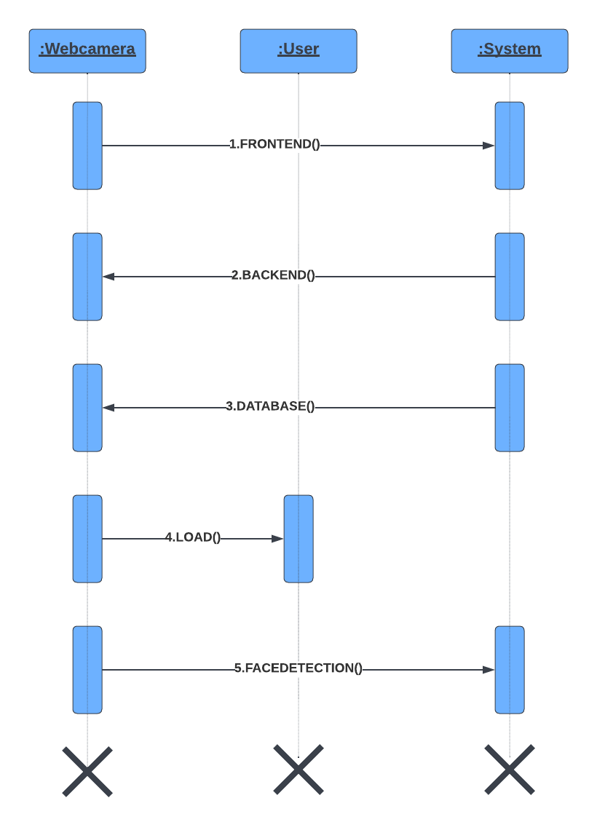

Figure 3.4: Sequence Diagram For Facial Expression Recogination For Restaurants Based On Scoring.

## ACTIVITY DIAGRAM

Activity diagrams are graphical representations of workflows of stepwise activities and actions with support for choice, iteration and concurrency. In the Unified Modeling Language, activity diagrams can be used to describe the business and operational step-by-step workflows of components in a system. An activity diagram shows the overall flow of control.

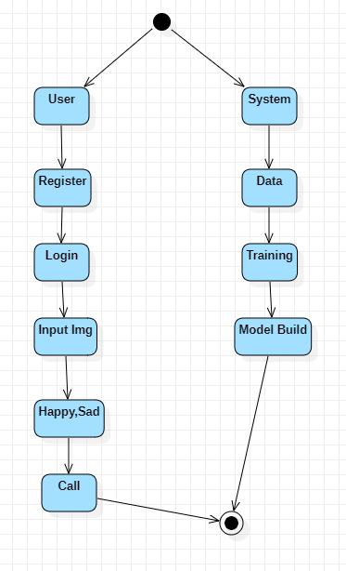

Figure 3.5: Activity Diagram For Facial Expression Recogination For Restaurants Based On Scoring.

# 4.MODULES

### System

* 1. **User**

### System:

* + 1. **Create Dataset:**

The dataset containing images of the hand gestures are considered.

### Pre-processing:

Resizing and reshaping the images into appropriate format to train our model.

### Training:

Use the pre-processed training to train our model using CNN algorithm.

### User:

* + 1. **Open CV**

With the help of OpenCv, we are recording the different gestures of hand numerical signs and recognizing the

# 5.LITERATURE SURVEY

The project introduced an audiobook Pingfan de Shijie with plentiful information of emotions. Via the emotion labeling of more than 6000 sentences respectively depending on context and audio, the commonalities and differences of the two layers of annotation were checked from two aspects: whether the sentences are neutral or un-neutral, and which emotional categories these sentences belong to. The results show that the subjective sentences in text layer can be read as neutral speech sentences, while large amount of objective sentences in text layer must be read as effective speech sentences. Finally, the causes to the annotation difference were analyzed and considerations in the process of emotional modeling from text to speech in speech synthesis were raised by this project.

Most automatic expression analysis systems attempt to recognize a small set of prototypic expressions (e.g. happiness and anger). Such prototypic expressions, however, occur infrequently. Human emotions and intentions are communicated more often by changes in one or two discrete facial features. We develop an automatic system to analyze subtle changes in facial expressions based on both permanent facial features (brows, eyes, mouth) and transient facial features (deepening of facial furrows) in a nearly frontal image sequence. Unlike most existing systems, our system attempts to recognize fine-grained changes in facial expression based on Facial Action Coding System (FACS) action units (AUs), instead of six basic expressions (e.g. happiness and anger). Multi-state face and facial component models are proposed for tracking and modeling different facial features, including lips, eyes, brows, cheeks, and their related wrinkles and facial furrows. Then we convert the results of tracking to detailed parametric descriptions of the facial features. With these features as the inputs, 11 lower face action units (AUs) and 7 upper face AUs are recognized by a neural network algorithm. A recognition rate of 96.7% for lower face AUs and 95% for upper face AUs is obtained respectively. The recognition results indicate that our system can identify action units regardless of whether they occurred singly or in combinations.

The human face is rich of information and plays important roles in daily communication such as expressing the emotions nonverbally. Facial expression comes in all varieties. Some are intense and sustained while others are subtle and fleeting. Much progress has been made to build computer systems that recognize facial expression for human computer interaction such as affective computing which apply the automatic facial recognition techniques in human computer interaction where the main idea is that the computer could better adjust its behavior

to user's current emotion. Other possible area that could use the advance technology of Facial expression recognition system is the customer satisfaction measurement. The expression of customer being served at the counter is captured to evaluate the satisfaction of the customer. This multimedia approach of customer satisfaction measurement is an alternative of the conventional way of collecting customers' response.

Feedback Evaluation is a necessary part of any institute to maintain and monitor the academic quality of the system. Traditionally, a questionnaire based system is used to evaluate the performance of teachers of an institute. Here, we propose an automatic evaluation system based on sentiment analysis, which shall be more versatile and meaningful than existing system. In our proposed system, feedback is collected in the form of running text and sentiment analysis is performed to identify important aspects along with the orientations using supervised and semi supervised machine learning techniques.

### [1].Hussain Saeed,Ali Shouman,Malis Elfar,Mostafa Shabka,Shikharesh Majumdar,and Chung Horng-Lung “Near-field communication sensors and cloud based smart restaurant management system,” in Proceedingsof the 2016 IEEattern Recognition(CVPRE 3rd World Forum on Internet of Things(WT-IOT),pp.686- 691,2016:

When members of respondents 3 to 5 unions obstructed loading and unloading work in the petitioner's unit, the writ petition was filed. Despite representations to police authorities, the petitioner received no police assistance. The writ petition seeks a direction to the Sub Inspector of Police, Kottappady, to provide effective and sufficient police protection to the petitioner in order for him to carry out loading and unloading operations in his industrial unit by employing registered headload workers without interference from members of respondents 3 to 5 unions.The petitioner runs a small scale industrial enterprise by name 'Kunnathukudy Cement Products', in Kottappady Panchayath. The petitioner's unit is engaged in manufacturing concrete blocks and pavement tiles. The petitioner has employed five permanent workers in his unit. Three workers are engaged for loading and unloading work and Exts.P2(a) to P2(c) identity cards were issued to those three persons under Rule 26A of the Kerala Headload Workers Rules.

### [2].Florian Schroff,Dmitry Kalenichenko,and James Philbin,”FaceNet:a unified embedding for face recognition and clustering” n Proceedings of the 2015 IEEE Conference on Computer Vision and Pattern Recognition(CVPR),pp.815-823,2015

Data Science and Machine Learning have established modern automation trends. It is considerate to simplify our day-to-day activities related to these domains. One such task is submitting the same personal information over and over again when filling out any online form for academic or other purposes. The repetition appears to be dilatory. Furthermore, the use of machine learning promotes the idea of automating the re-iteration of personal details each time we fill out a form, rather than manual entry. To avoid the above redundancy, we proposed implementing "Exam Form Automation Using Facial Recognition," which includes real-time face recognition using a webcam, pre-storing data on web servers using Python's Panda and NumPy libraries, and then automating form entries using Python's Selenium library. The system captures a real-time image of a user and extracts specific information from data stored on a web server. As a result, the tedious procedure of manual entry is avoided.

### [3].Andrew G. Howard,Menglong zhu,Bo Chen,Dmitry Kalenichenko, Weijun Wang,Tobias sWeyand,Macro Andreeto,and Hartwig Adam,”MobileNets:efficient convolutional neural networks for mobile vision applications,”

We present MobileNets, a class of efficient models for mobile and embedded vision applications. MobileNets are based on a streamlined architecture that builds light weight deep neural networks using depth-wise separable convolutions. We present two simples global hyperparameters for efficiently balancing latency and accuracy. Based on the constraints of the problem, these hyper-parameters enable the model builder to select the appropriately sized model for their application. We present extensive experiments on resource and accuracy tradeoffs and demonstrate strong performance on ImageNet classification compared to other popular models. The effectiveness of MobileNets is then demonstrated in a variety of applications and use cases, including object detection, finegrain classification, face attributes, and large scale geo-localization.

### [4].Janne Tommala,Pedram Ghazi,Bishwo Adhikara,and Hekki Huttunen,”Real time system for facial analysis,” in Proceedings of the 7 th European Workshop on Visual Information Processing

The anatomy of a real-time facial analysis system is described in this paper. When users appear in front of the camera, the system recognises their age, gender, and facial expression. All components are based on convolutional neural networks, the accuracy of which we investigate using widely used training and evaluation sets. The description of the interplay between processing threads for frame grabbing, face detection, and the three types of recognition is a key contribution of the work. The python code for running the system is available for download and makes use of common libraries such as keras/tensorflow, opencv, and dlib.

**6.IMPLEMENTATION**

**6.1 SAMPLE CODE**

View.py

from django.shortcuts import render, redirect

from django.contrib.auth.models import User

from django.contrib.auth import authenticate, login, logout

from django.views.decorators.csrf import csrf_exempt

from django.http import HttpResponse

import base64

import test

from .models import *

# Create your views here.

def index(request):

return render(request, 'index.html')

def signup(request):

if(request.method == 'POST'):

first_name = request.POST['first_name']

last_name = request.POST['last_name']

email = request.POST['email']

password = request.POST['password']

user = User.objects.create_user(username=email, email=email,password=password, first_name=first_name, last_name=last_name)

user.save()

return redirect('index')

TEST.PY

import tensorflow as tf

import numpy as np

def pred(path):

model = tf.keras.models.load_model('model1.h5')

img_height = 128

img_width = 128

img = tf.keras.utils.load_img(

path, target_size=(img_height, img_width)

)

img_array = tf.keras.utils.img_to_array(img)

img_array = tf.expand_dims(img_array, 0) # Create a batch

predictions = model.predict(img_array)

score = tf.nn.softmax(predictions[0])

class_names = ['Happy', 'Neutral', 'Sad']

x = class_names[np.argmax(score)]

print(x)

pred('Dataset/dataset/test/happiness/happiness_1_193.png')

INDEX.HTML

!doctype html>

<html lang="en">

<head>

<meta charset="utf-8">

<meta name="viewport" content="width=device-width, initial-scale=1">

<meta name="description" content="">

<meta name="author" content="">

<title>Kind Heart Charity - Free Bootstrap 5.2.2 CSS Template</title>

<!-- CSS FILES -->

<link href="/static/home/css/bootstrap.min.css" rel="stylesheet">

<link href="/static/home/css/bootstrap-icons.css" rel="stylesheet">

<link href="/static/home/css/templatemo-kind-heart-charity.css" rel="stylesheet">

<!--

TemplateMo 581 Kind Heart Charity

https://templatemo.com/tm-581-kind-heart-charity

-->

</head>

<body id="section_1">

<nav class="navbar navbar-expand-lg bg-light shadow-lg">

<div class="container">

<a class="navbar-brand" href="index.html">

<img src="/static/home/img/logo.png" class="logo img-fluid" alt="Kind Heart Charity">

<span>

Facial Expression Recognition Based Scoring System

<small>For Restaurants</small>

</span>

</a>

<button class="navbar-toggler" type="button" data-bs-toggle="collapse" data-bs-target="#navbarNav" aria-controls="navbarNav" aria-expanded="false" aria-label="Toggle navigation">

<span class="navbar-toggler-icon"></span>

</button>

<div class="collapse navbar-collapse" id="navbarNav">

<ul class="navbar-nav ms-auto">

<li class="nav-item">

<a class="nav-link click-scroll" href="#top">Home</a>

</li>

<li class="nav-item">

<a class="nav-link click-scroll" href="#section_2">About</a>

</li>

<li class="nav-item">

<a class="nav-link click-scroll" href="#section_6">SignUp</a>

</li>

<li class="nav-item">

<a class="nav-link click-scroll" href="#section_7">SignIn</a>

</li>

</ul>

</div>

</div>

</nav>

<main>

<section class="hero-section hero-section-full-height">

<div class="container-fluid">

<div class="row">

<div class="col-lg-12 col-12 p-0">

<div id="hero-slide" class="carousel carousel-fade slide" data-bs-ride="carousel">

<div class="carousel-inner">

<div class="carousel-item active">

<img src="/static/home/img/slide/volunteer-helping-with-donation-box.jpg" class="carousel-image img-fluid" alt="...">

<div class="carousel-caption d-flex flex-column justify-content-end">

<h1>be a Kind Heart</h1>

<p>Professional charity theme based on Bootstrap

</p>

</div>

</div>

<div class="carousel-item">

<img src="/static/home/img/slide/volunteer-selecting-organizing-clothes-donations-charity.jpg" class="carousel-image img-fluid" alt="...">

<div class="carousel-caption d-flex flex-column justify-content-end">

<h1>Non-profit</h1>

<p>You can support us to grow more</p>

</div>

</div>

<div class="carousel-item">

<img src="/static/home/img/slide/medium-shot-people-collecting-donations.jpg" class="carousel-image img-fluid" alt="...">

<div class="carousel-caption d-flex flex-column justify-content-end">

<h1>Humanity</h1>

<p>Please tell your friends about our website</p>

</div>

</div>

</div>

<button class="carousel-control-prev" type="button" data-bs-target="#hero-slide" data-bs-slide="prev">

<span class="carousel-control-prev-icon" aria-hidden="true"></span>

<span class="visually-hidden">Previous</span>

</button>

<button class="carousel-control-next" type="button" data-bs-target="#hero-slide" data-bs-slide="next">

<span class="carousel-control-next-icon" aria-hidden="true"></span>

<span class="visually-hidden">Next</span>

</button>

</div>

</div>

</div>

</div>

</section>

<section class="section-padding">

<div class="container">

<div class="row">

<div class="col-lg-10 col-12 text-center mx-auto">

<h2 class="mb-5">Welcome to Kind Heart Charity</h2>

</div>

<div class="col-lg-3 col-md-6 col-12 mb-4 mb-lg-0">

<div class="featured-block d-flex justify-content-center align-items-center">

<a href="donate.html" class="d-block">

<img src="/static/home/img/icons/hands.png"class="featured**-**block-image img-fluid" alt="">

<p class="featured-block-text">Become a <strong>volunteer</strong></p>

</a>

</div>

</div>

<div class="col-lg-3 col-md-6 col-12 mb-4 mb-lg-0 mb-md-4">

<div class="featured-block d-flex justify-content-center align-items-center">

<a href="donate.html" class="d-block">

<img src="/static/home/img/icons/heart.png" class="featured-block-image img-fluid" alt="">

<p class="featured-block-text"><strong>Caring</strong> Earth</p>

</a>

</div>

</div>

<div class="col-lg-3 col-md-6 col-12 mb-4 mb-lg-0 mb-md-4">

<div class="featured-block d-flex justify-content-center align-items-center">

<a href="donate.html" class="d-block">

<img src="/static/home/img/icons/receive.png" class="featured-block-image img-fluid" alt="">

<p class="featured-block-text">Make a<strong>Donation</strong></p>

</a>

</div>

</div>

<div class="col-lg-3 col-md-6 col-12 mb-4 mb-lg-0">

<div class="featured-block d-flex justify-content-center align-items-center">

<a href="donate.html" class="d-block">

<img src="/static/home/img/icons/scholarship.png" class="featured-block-image img-fluid" alt="">

<p class="featured-block-text"><strong>Scholarship</strong> Program</p>

</a>

</div>

</div>

</div>

</div>

</section>

<section class="section-padding section-bg" id="section_2">

<div class="container">

<div class="row">

<div class="col-lg-6 col-12 mb-5 mb-lg-0">

<img src="/static/home/img/group-people-volunteering-foodbank-poor-people.jpg" class="custom-text-box-image img-fluid" alt="">

</div>

<div class="col-lg-6 col-12">

<div class="custom-text-box">

<h2 class="mb-2">Our Story</h2>

<h5 class="mb-3">Kind Heart Charity, Non-Profit Organization</h5>

<p class="mb-0">This is a Bootstrap 5.2.2 CSS template for charity organization websites. You can feel free to use it. Please tell your friends about TemplateMo website. Thank you. HTML CSS files updated on 20 Oct 2022.</p>

</div>

<div class="row">

<div class="col-lg-6 col-md-6 col-12">

<div class="custom-text-box mb-lg-0">

<h5 class="mb-3">Our Mission</h5>

<p>Sed leo nisl, posuere at molestie ac, suscipit auctor quis metus</p>

<ul class="custom-list mt-2">

<li class="custom-list-item d-flex">

<i class="bi-check custom-text-box-icon me-2"></i>

Charity Theme

</li>

<li class="custom-list-item d-flex">

<i class="bi-check custom-text-box-icon me-2"></i>

Semantic HTML

</li>

</ul>

</div>

</div>

<div class="col-lg-6 col-md-6 col-12">

<div class="custom-text-box d-flex flex-wrap d-lg-block mb-lg-0">

<div class="counter-thumb">

<div class="d-flex">

<span class="counter-number" data-from="1" data-to="2009" data-speed="1000"></span>

<span class="counter-number-text"></span>

</div>

<span class="counter-text">Founded</span>

</div>

<div class="counter-thumb mt-4">

<div class="d-flex">

<span class="counter-number" data-from="1" data-to="120" data-speed="1000"></span>

<span class="counter-number-text">B</span>

</div>

<span class="counter-text">Donations</span>

</div>

</div>

</div>

</div>

</div>

</div>

</div>

</section>

<section class="contact-section section-padding" id="section_6">

<div class="container">

<div class="row">

<div class="col-lg-5 col-12 mx-auto">

<form class="custom-form contact-form" action="signup" method="post" role="form">

<h2>Sign Up</h2>

{% csrf_token %}

<div class="row">

<div class="col-lg-6 col-md-6 col-12">

<input type="text" name="first_name" id="first-name" class="form-control" placeholder="Jack" required>

</div>

<div class="col-lg-6 col-md-6 col-12">

<input type="text" name="last_name" id="last-name" class="form-control" placeholder="Doe" required>

</div>

</div>

<input type="email" name="email" id="email" pattern="[^ @]@[^ @]" class="form-control" placeholder="Jackdoe@gmail.com" required>

<input type="password" name="password" placeholder="Password" class="form-control" id="password"></input>

<button type="submit" class="form-control">Sign Up</button>

</form>

</div>

<div class="col-lg-5 col-12 mx-auto">

<form class="custom-form contact-form" action="signin" method="post" role="form">

<h2>Sign In</h2>

{% csrf_token %}

<div class="row">

<br />

<br />

<br />

</div>

<input type="email" name="email" id="email" pattern="[^ @]@[^ @]" class="form-control" placeholder="Jackdoe@gmail.com" required>

<input type="password" name="password" placeholder="Password" class="form-control" id="password"></input>

<button type="submit" class="form-control">Sign In</button>

</form>

</div>

</div>

</div>

</section>

</main>

<footer class="site-footer">

<div class="container">

<div class="row">

<div class="col-lg-3 col-12 mb-4">

<img src="/static/home/img/logo.png" class="logo img-fluid" alt="">

</div>

<div class="col-lg-4 col-md-6 col-12 mb-4">

<h5 class="site-footer-title mb-3">Quick Links</h5>

<ul class="footer-menu">

<li class="footer-menu-item"><a href="#" class="footer-menu-link">Our Story</a></li>

<li class="footer-menu-item"><a href="#" class="footer-menu-link">Newsroom</a></li>

<li class="footer-menu-item"><a href="#" class="footer-menu-link">Causes</a></li>

<li class="footer-menu-item"><a href="#" class="footer-menu-link">Become a volunteer</a></li>

<li class="footer-menu-item"><a href="#" class="footer-menu-link">Partner with us</a></li>

</ul>

</div>

<div class="col-lg-4 col-md-6 col-12 mx-auto">

<h5 class="site-footer-title mb-3">Contact Infomation</h5>

<p class="text-white d-flex mb-2">

<i class="bi-telephone me-2"></i>

<a href="tel: 120-240-9600" class="site-footer-link">

120-240-9600

</a>

</p>

<p class="text-white d-flex">

<i class="bi-envelope me-2"></i>

<a href="mailto:info@yourgmail.com" class="site-footer-link">

donate@charity.org

</a>

</p>

<p class="text-white d-flex mt-3">

<i class="bi-geo-alt me-2"></i>

Akershusstranda 20, 0150 Oslo, Norway

</p>

<a href="#" class="custom-btn btn mt-3">Get Direction</a>

</div>

</div>

</div>

<div class="site-footer-bottom">

<div class="container">

<div class="row">

<div class="col-lg-6 col-md-7 col-12">

<p class="copyright-text mb-0">Copyright © 2036 <a href="#">Kind Heart</a> Charity Org.

Design: <a href="https://templatemo.com" target="_blank">TemplateMo</a></p>

</div>

<div class="col-lg-6 col-md-5 col-12 d-flex justify-content-center align-items-center mx-auto">

<ul class="social-icon">

<li class="social-icon-item">

<a href="#" class="social-icon-link bi-twitter"></a>

</li>

<li class="social-icon-item">

<a href="#" class="social-icon-link bi-facebook"></a>

</li>

<li class="social-icon-item">

<a href="#" class="social-icon-link bi-instagram"></a>

</li>

<li class="social-icon-item">

<a href="#" class="social-icon-link bi-linkedin"></a>

</li>

<li class="social-icon-item">

<a href="https://youtube.com/templatemo" class="social-icon-link bi-youtube"></a>

</li>

</ul>

</div>

</div>

</div>

</div>

</footer>

**<!--** JAVASCRIPT FILES -->

<script src="/static/home/js/jquery.min.js"></script>

<script src="/static/home/js/bootstrap.min.js"></script>

<script src="/static/home/js/jquery.sticky.js"></script>

<script src="/static/home/js/click-scroll.js"></script>

<script src="/static/home/js/counter.js"></script>

<script src="/static/home/js/custom.js"></script>

</body>

</html>

# 7.SCREENSHOTS

## 7.1 HOME PAGE

## 

## SCREENSHOT 7.1 Home page.

## Here is the home page for facial expression recogination in restaurants based on scoring where we can see About, Sign Up, Sign In, This page is the main page we can navigate to other pages through this page.

**7.2 ABOUT PAGE**

## 

## SCREENSHOT 7.2 About page.

## Here is about page.Where website users can clearly see it and know more information about the website.

## 7.3 LOGIN AND REGISTRATION PAGE

## 

## SCREENSHOT 7.3 Login and Registration page.

Here is the login and registration page .For sign up we use first name, last name,email id and password, For sign in we use email id and password.

**7.4 USER HOMEPAGE**

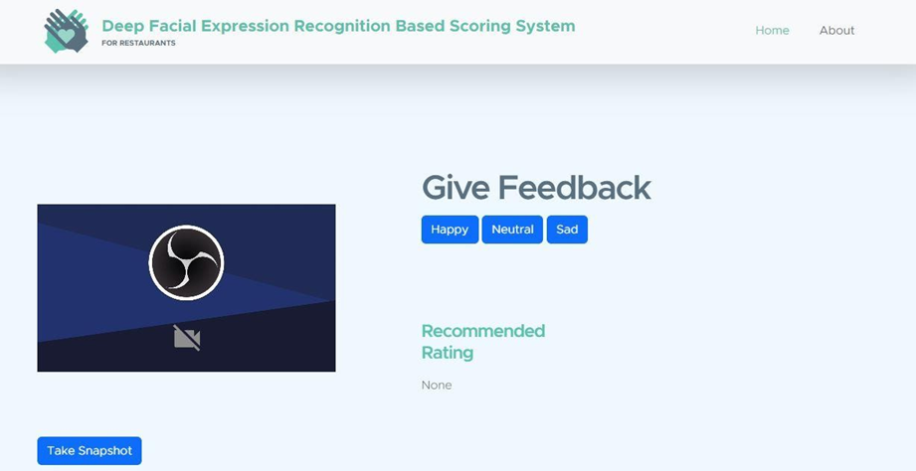

## SCREENSHOT 7.4 User homepage.

Here is the user homepage. where user take snapshot by clicking on take snapshot button and the system automatically gives the results through the user facial expression. Here is three different expressions happy, neutral, sad. According to our face expression the system gives accurate results.

# 7.5 HAPPY EXPRESSION PAGE

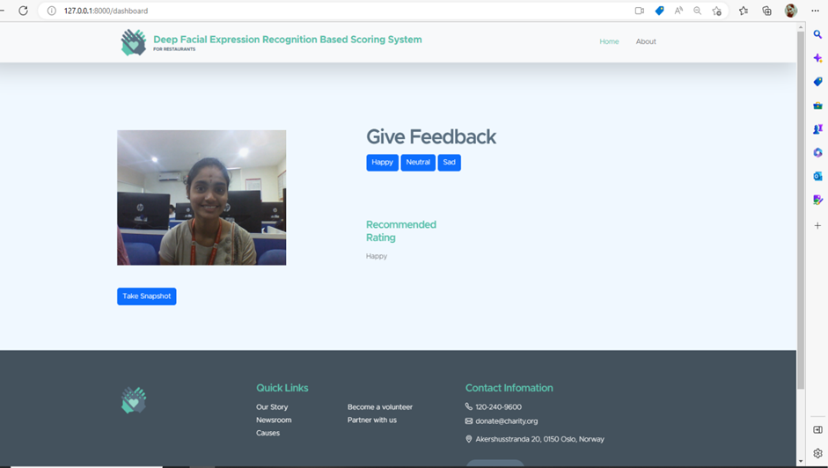

## SCREENSHOT 7.5 Happy Expression Page.

## Here is the happy expression page. Where User happy expression is displayed. The user have to keep there face infront of system it captures the image after we clicking on take snapshot button. If the user is satisfied with the restaurant food the user have to give happy expression.

# 7.6 SAD EXPRESSION PAGE

# 

## SCREENSHOT 7.6 Sad Expression Page.

## Here is the sad expression page. Where User sad expression is displayed. The user have to keep there face infront of system it captures the image after we clicking on take snapshot button. If the user is disappointed with the restaurant food the user have to give sad expression.

# 7.7 NEUTRAL EXPRESSION PAGE

# 

## SCREENSHOT 7.7 Neutral Expression page.

# Here is the Neutral expression page. Where User neutral expression is displayed. The user have to keep there face infront of system it captures the image after we clicking on take snapshot button. If the user is normally satisfied with the restaurant food the user have to give neutral expression

## 8.TESTING

**INTRODUCTION TO TESTING**

The purpose of testing is to discover errors. Testing is the process of trying to discover every conceivable fault or weakness in a work product. It provides a way to check the functionality of components, sub-assemblies, assemblies and/or a finished product It is the process of exercising software with the intent of ensuring that the Software system meets its requirements and user expectations and does not fail in an unacceptable manner. There are various types of test. Each test type addresses a specific testing requirement.

# TYPES OF TESTING

## 8.1.1 UNIT TESTING

Unit testing involves the design of test cases that validate that the internal program logic is functioning properly, and that program inputs produce valid outputs. All decision branches and internal code flow should be validated. It is the testing of individual software units of the application .it is done after the completion of an individual unit before integration. This is a structural testing, that relies on knowledge of its construction and is invasive. Unit tests perform basic tests at component level and test a specific business process, application, and/or system configuration. Unit tests ensure that each unique path of a business process performs accurately to the documented specifications and contains clearly defined inputs and expected results.

## INTEGRATION TESTING

Integration tests are designed to test integrated software components to determine if they actually run as one program. Testing is event driven and is more concerned with the basic outcome of screens or fields. Integration tests demonstrate that although the components were individually satisfaction, as shown by successfully unit testing, the combination of components is correct and consistent. Integration testing is specifically aimed at exposing the problems that arise from the combination of components.

## FUNCTIONAL TESTING

Functional tests provide systematic demonstrations that functions tested are available as specified by the business and technical requirements, system documentation, and user manuals.

Functional testing is centered on the following items:

Valid Input : identified classes of valid input must be accepted. Invalid Input : identified classes of invalid input must be rejected. Functions : identified functions must be exercised.

Output : identified classes of application outputs must be exercised. Systems/Procedures: interfacing systems or procedures must be invoked.

Organization and preparation of functional tests is focused on requirements, key functions, or special test cases. In addition, systematic coverage pertaining to identify Business process flows; data fields, predefined processes, and successive processes must be considered for testing. Before functional testing is complete, additional tests are identified and the effective value of current tests is determined.

# 8.2 TESTCASES

|  |  |  |
| --- | --- | --- |
| **Input** | **Output** | **Result** |
| Input text | Deep facial expression based scoring Restaurant | Success |

* 1. **TEST CASES MODEL BUILDING:**

|  |  |  |  |  |  |
| --- | --- | --- | --- | --- | --- |
| **S.NO** | **Test cases** | **I/O** | **Expected O/T** | **Actual O/T** | **P/F** |
| 1 | Read the dataset. | Dataset path. | Dataset need to  read successfully. | Dataset  fetched successfully. | P |
| 2 | Performing pre-processing on the dataset | Pre- processing part takes  place | Pre-processing should be performed on  dataset | Pre- processing successfully  completed. | P |
| 3 | Model Building | Model Building for the clean data | Need to create model using required  algorithms | Model Created Successfully. | P |
| 4 | Classification | Input image provided. | Output should be the emotion identification is done. | Model classified successfully | P |

# 9.CONCLUSION AND FUTURE SCOPE

## 9.1 PROJECT CONCLUSION

In this project, a restaurant rating system was introduced by recognizing facial expressions by scanning images and performing principal component analysis on which Haar features were compared. The image is now classified and detected as happy, sad, or angry. In this paper, we basically recognize facial expressions for restaurant scoring and categories them as happy, satisfied, or disappointed.

## 9.2 FUTURE SCOPE

This project provides an overview of various facial expression recognition techniques and architectures for extracting important facial features. Detailed information on the various datasets used in facial expression recognition is provided, along with the necessary information. Recent feature extraction techniques with comparison and recent challenges are covered, which will help other researchers overcome problems with existing methods and improve accuracy. Many researchers in fields such as human interaction systems, mental disease detection, and affect recognition have been drawn to facial expression recognition (FER).

# 10. BIBLIOGRAPHY

## 10.1 REFERENCES

1. Hussain Saeed,Ali Shouman,Malis Elfar, Mostafa Shaba, Shikharesh Majumdar, and Chung Horng-Lung, “Near-field communication sensors and cloud based smart restaurant management system,” in Proceedingsof the 2016 IEEattern Recognition(CVPRE 3rd World Forum on Internet of Things(WT-IOT),pp.686-691,2016
2. Florian Schroff,Dmitry Kalenichenko, and James Philbin,”FaceNet:a unified embedding for face recognition and clustering” n Proceedings of the 2015 IEEE Conference on Computer vision and pattern recognition.
3. Andrew G. Howard, Menglong zhu, Bo Chen, Dmitry Kalenichenko, Weijun Wang,Tobias sWeyand, Macro Andreeto, and Hartwig Adam,”MobileNets: efficient convolutional neural networks for mobile vision applications.
4. Janne Tommala, Pedram Ghazi ,B ishwo Adhikara, and Hekki Huttunen,”Real time system for facial analysis,” in Proceedings of the 7 th European Workshop on Visual Information Processing.
5. Muscles Of The Face And Their Functions Facial Expression Recognition (Face recognition Techniques) Part 1 M Anatomy "Muscles of the Face and Their Functions facial Expression Recognition (Face Recognition Techniques).
6. FERA 2015-Second Facial Expression Recognition and Analysis challenge - IEEE Conference publication.
7. Dr. Chetana Tukkoji et.al “ITM-CLD: Intelligent traffic management to handling cloudlets of the large data”, published in CSOC 2018-Cybernetics and Algorithms in Intelligent Systems, book series AISC- volume 765, 17 May 2018.
8. https://becominghuman.ai/smart-face-control-how-facial-recognitionchanges-different- industries
9. Dr. Chetana Tukkoji et.al “Distribution of Data Handling in Cloud Asset”, International journal of engineering and advanced technology, volume-9, issue-3 Feb 2020.
10. Facial Expression Recognition Using Local Binary Pattern (LBP ) A Saputra T A B Wirayuda A. Saputra and T. A. B. Wirayuda, "Facial Expression Recognition Using Local binary Pattern ( LBP ).

**10.2 GITHUB LINK**